 | 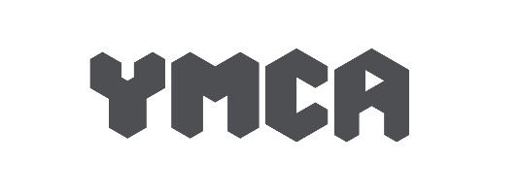

Service User Complaints Policy

Policy name | Service User Complaints Policy
Department | General
Author | Becky Parke
Responsible Trustee
Approved by Board | 24th May 2022
Review Date | May 2025

Aim of policy

YMCA Crewe wishes to provide the best possible service. The aim of the Service User Complaints Policy is to ensure that the principle stakeholders in YMCA Crewe, the service users, have a clear and robust route for making any complaints related to the service or the staff (ie not complaints from one service user about another). Complaints and suggestions should be viewed as a way to improve our practice, and therefore be welcomed and encouraged by staff

Policy statements

- YMCA will make the complaints process visibile, open and transparent. Service users are made aware of how to make a complaint on entry to the service and information about how to complain is available in a number of locations e.g. the Licence Agreement, website and the back of all service users room door’s.
- YMCA Crewe will make the complaints process accessible to all, and available in a number of different formats such as digital and written.
- Complaint forms and guidelines with information on how to make a complaint will be easily available in plain language to those who wish to express a view.
- YMCA Crewe will aim to create an atmosphere in which service users feel able to provide various forms of feedback on the service they recieive.
- Staff are trained to respond correctly to complaints of any kind. Complaints policy training is included in the induction training for all new staff and updated as indicated by any changes in the policy and procedures and in the light of the experience of addressing complaints.
- YMCA Crewe will ensure that service users have access to help in making a complaint should they request this. When supported by an appropriate person, that person will not attempt to influence the nature or substance of the complaint, but just assist with completing the form.
- Any complaint received will be investigated and responded to within an appropriate timeframe; this will be five working days whenever possible. If this is not possible, then an explanation of the reason will be incorporated into the response when it is made.
- YMCA Crewe intends to learn from complaints; any learning from them will be incorporated into policies and procedures.

Responsibility for implementation and monitoring

- A named person is always responsible for the administration of the procedure.
- Complaints forms are initially given to the Head of Corporate and Community Services, who will pass them to a Team Leader or Senior Manager to investigate and resolve as appropriate.
- The Company Secretary will advise other Senior Managers of content if appropriate.
- The Chief Executive Officer will sign off all complaints once they have been dealt with satisfactorily.

Reporting

An annual Board report will be prepared, summarising

- the number of forms received
- the nature of the complaint
- details of responses

Some funders and comissioners require service user complaints to be reported. For example, for the Housing Related Support 16+ Contact with Children’s Social Care, Complaints and Compliments are reported quartly via a Performance Monitoring Framework document.

